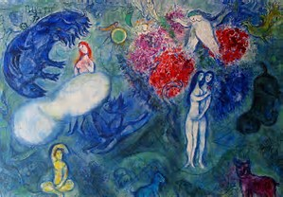
https://www.bing.com/images/search?q=chagall+das+Paradies&id=DE6D6E638CD1C6BFBD02DBCF5DFA2C7F82798050&FORM=IQFRBA

